LABORATORIYA ISHI 12

Mavzu: DOM orqali elementlarni qo‘shish va

o‘zgartirish

1. Ishning maqsadi
Ushbu laboratoriya ishining maqsadi — JavaScript orqali DOM (Document Object Model) bilan ishlashni nazariy jihatdan o‘rganish, web-sahifadagi elementlarni yaratish, qo‘shish va o‘zgartirish tamoyillarini tushunishdir.
Talaba:
DOM tushunchasini va uning web-ilovalardagi rolini anglaydi;
JavaScript orqali sahifadagi elementlar bilan interaktiv ishlash imkoniyatini tushunadi;
Element yaratish, ularni qo‘shish va mavjud elementlarni o‘zgartirish tamoyillarini biladi;
Web-ilovalarda dinamik kontent yaratish va boshqarish konseptsiyasini o‘zlashtiradi.

2. Nazariy qism

2.1 DOM tushunchasi
DOM (Document Object Model) — bu web-sahifani obyektlar daraxti (tree) shaklida ifodalash modelidir. DOM sahifadagi har bir HTML elementi obyekt sifatida ko‘riladi va JavaScript yordamida unga murojaat qilish, o‘zgartirish yoki yangi element qo‘shish mumkin.
DOM yordamida:
Elementlarning matnini o‘zgartirish;
Yangi elementlar yaratish va sahifaga qo‘shish;
Mavjud elementlarni olib tashlash yoki ularning atributlarini o‘zgartirish mumkin.
2.2 Elementlarni tanlash
DOM bilan ishlash uchun avval sahifadagi elementlarni tanlash zarur. Buning uchun asosiy metodlar:
document.getElementById("id") – ID orqali elementni tanlaydi;
document.getElementsByClassName("class") – class nomi orqali;
document.getElementsByTagName("tag") – tag nomi orqali;
document.querySelector() va document.querySelectorAll() – CSS selektorlar orqali.
Element tanlanganidan so‘ng, unga matn, atribut yoki boshqa elementlarni qo‘shish mumkin.

2.3 Yangi element yaratish
DOM orqali yangi element yaratish jarayoni quyidagi bosqichlardan iborat:
document.createElement("tag") yordamida yangi element yaratiladi;
element.textContent yoki element.innerHTML yordamida matn qo‘shiladi;
element.setAttribute() yordamida atributlar belgilanadi;
parent.appendChild(element) yoki parent.insertBefore(element, reference) orqali sahifaga qo‘shiladi.
2.4 Mavjud elementlarni o‘zgartirish
Mavjud elementlar bilan ishlash quyidagi imkoniyatlarni beradi:
Matnni o‘zgartirish: element.textContent yoki element.innerHTML;
Atributlarni o‘zgartirish: element.setAttribute() yoki element.className yordamida;
Elementni olib tashlash: parent.removeChild(element);
CSS uslubini o‘zgartirish: element.style.property = value.

2.5 DOM manipulyatsiyasining afzalliklari
Web-sahifalar dinamik va interaktiv bo‘ladi;
Foydalanuvchi harakatlariga mos kontent yaratish mumkin;
Sahifa elementlarini tez va samarali boshqarish imkoniyati mavjud;
Kodni modul va boshqarilishi oson qilib tuzish mumkin.
2.6 Xavfsizlik va ehtiyot choralari
DOM manipulyatsiyasi orqali foydalanuvchi tomonidan kiritilgan ma’lumotlar xavfli bo‘lishi mumkin (XSS hujumlari);
InnerHTML ishlatilganda tashqi kodlarni sanitizatsiya qilish zarur;
DOM bilan ishlashda server-side tekshiruv bilan birgalikda xavfsizlikni ta’minlash muhimdir.
AMALIY QISM:
<!DOCTYPE html>
<html lang="uz">
<head>
<meta charset="UTF-8">
<title>JS DOM – Gul Do‘koni Interaktiv</title>
<style>
body{
margin:0;
font-family:Arial, sans-serif;
background:#fdf0f6;
}

header{
background:#e91e63;
color:white;
padding:20px;
text-align:center;
font-size:20px;
}

.flowers{
display:flex;
justify-content:center;
gap:20px;
flex-wrap:wrap;
padding:30px;
}

.flower{
width:200px;
background:white;
border-radius:10px;
box-shadow:0 4px 15px rgba(0,0,0,.2);
overflow:hidden;
cursor:pointer;
transition:0.3s;
text-align:center;
}

.flower img{
width:100%;
height:130px;
object-fit:cover;
}

.flower:hover{
transform:scale(1.05);
}

.content h3{
margin:10px 0 5px 0;
color:#c2185b;
}

.content p{
font-size:14px;
color:#555;
}

#output{
display:flex;
justify-content:center;
gap:15px;
flex-wrap:wrap;
margin-top:20px;
padding:20px;
}

#output .selected-flower{
width:180px;
border:2px solid #c2185b;
border-radius:10px;
background:white;
padding:10px;
text-align:center;
box-shadow:0 4px 10px rgba(0,0,0,.2);
}

#output .selected-flower img{
width:100%;
height:100px;
object-fit:cover;
margin-bottom:5px;
}
</style>
</head>
<body>

<header>
🌸 JavaScript: DOM orqali Gul Do‘koni
</header>

<section class="flowers" id="flowers-section">
</section>

<div id="output">
</div>

<script>
let flowers = [
{name:"Atirgul", desc:"Sevgi ramzi", img:"rasim 1.jpg"},
{name:"Lola", desc:"Bahor guli", img:"rasim 2.jpg"},
{name:"Orxideya", desc:"Nafis va chiroyli", img:"rasim 3.jpg"},
{name:"Liliya", desc:"Poklik ramzi", img:"rasim 4.jpg"},
{name:"Pion", desc:"Hashamatli gul", img:"rasim 5.jpg"},
{name:"Romashka", desc:"Oddiy va chiroyli", img:"rasim 6.jpg"},
{name:"Gerbera", desc:"Yorqin rangli gul", img:"rasim 7.jpg"},
{name:"Lavanda", desc:"Xushbo‘y gul", img:"rasim 8.jpg"}
];

let flowersSection = document.getElementById("flowers-section");
let outputDiv = document.getElementById("output");

flowers.forEach(function(flower){
let flowerDiv = document.createElement("div");
flowerDiv.classList.add("flower");

let img = document.createElement("img");
img.src = flower.img;

let contentDiv = document.createElement("div");
contentDiv.classList.add("content");

let h3 = document.createElement("h3");
h3.textContent = flower.name;

let p = document.createElement("p");
p.textContent = flower.desc;

contentDiv.appendChild(h3);
contentDiv.appendChild(p);
flowerDiv.appendChild(img);
flowerDiv.appendChild(contentDiv);

flowerDiv.addEventListener("click", function(){
let selectedFlower = document.createElement("div");
selectedFlower.classList.add("selected-flower");

let selImg = document.createElement("img");
selImg.src = flower.img;

let selTitle = document.createElement("h4");
selTitle.textContent = flower.name;

let selDesc = document.createElement("p");
selDesc.textContent = flower.desc;

selectedFlower.appendChild(selImg);
selectedFlower.appendChild(selTitle);
selectedFlower.appendChild(selDesc);

outputDiv.appendChild(selectedFlower);
});

flowersSection.appendChild(flowerDiv);
});
</script>

</body>
</html>

NATIJA :
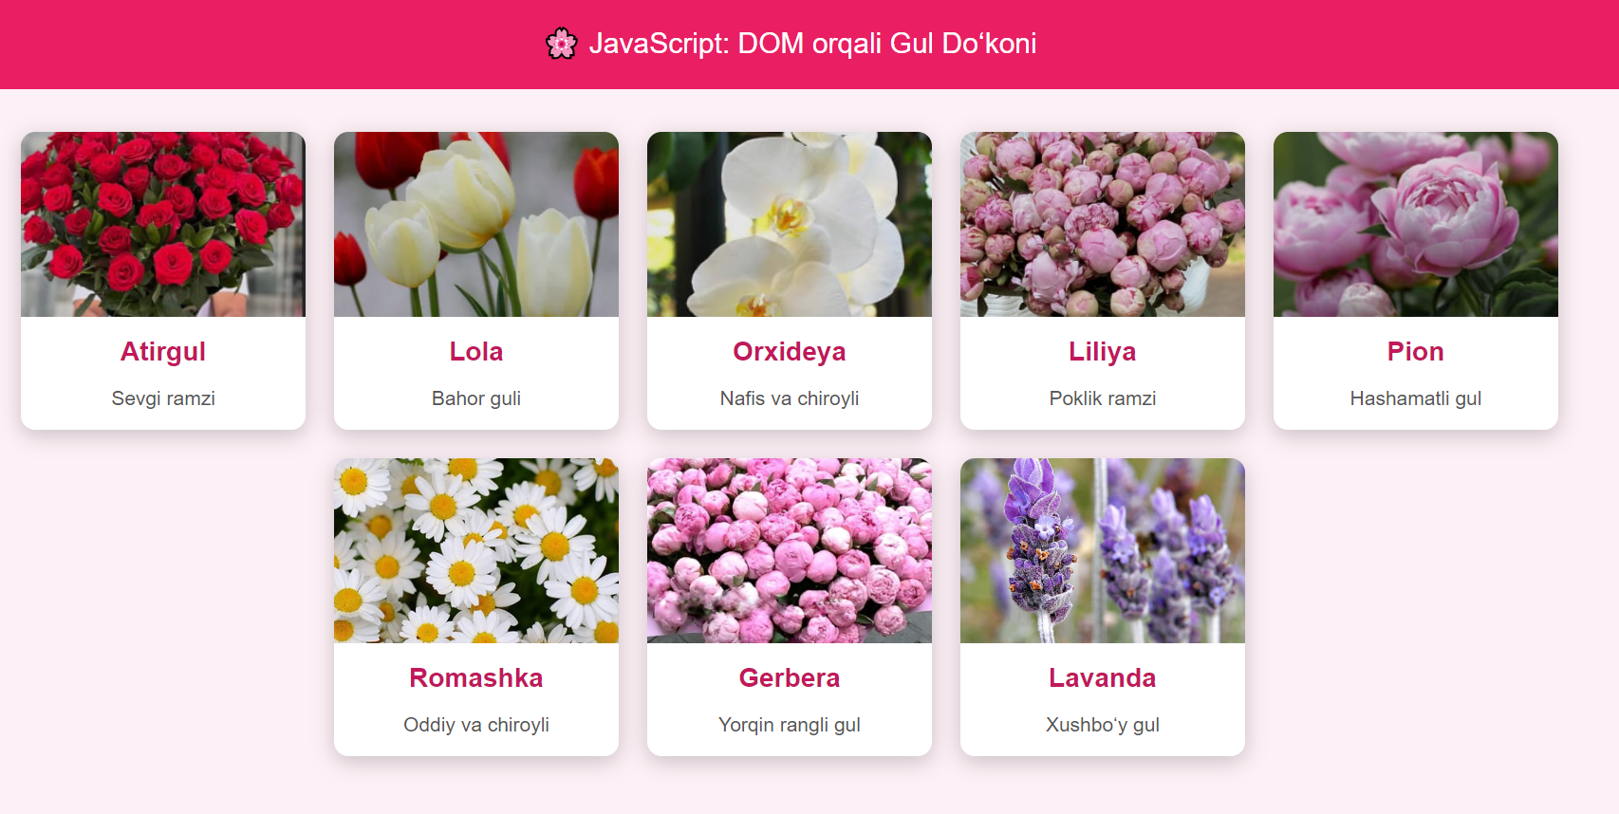

Xulosa
Ushbu laboratoriya ishida DOM orqali elementlarni qo‘shish va o‘zgartirish mavzusi nazariy jihatdan o‘rganildi. JavaScript yordamida web-sahifadagi elementlarni yaratish, ularni sahifaga qo‘shish va mavjud elementlarni o‘zgartirish jarayoni foydalanuvchi bilan interaktiv aloqani ta’minlashda muhim vosita ekanligi aniqlandi.
DOM manipulyatsiyasi web-ilovalarga dinamiklik va moslashuvchanlik beradi, foydalanuvchi tajribasini yaxshilaydi va sahifani boshqarishni soddalashtiradi. Shu sababli JavaScript orqali DOM bilan ishlashni bilish va uni to‘g‘ri qo‘llash har bir web-dasturchi uchun zarur ko‘nikma hisoblanadi.

